A Protocol for Causally Ordered Message Deliverly in Mobile Systems
Li-Hsing Yen, Ting-Lu Huang, Shu-Yuen Hwang
Department of Computer Science and Information Engineering
National Chiao Tung University
Hsinchu, Taiwan 300, R.O.C.
Abstract
This paper proposes an algorithm that enforces a useful property, namely, casual ordering, that delivers messages among mobile hosts. This property ensures that casually related messages directed to the same destibation will be delivered in an order consitent with their causality, which is important in applications that involve human interaction such as mobile e-mail systems and mobile news systems.
- Introduction
- Problem Definition
- 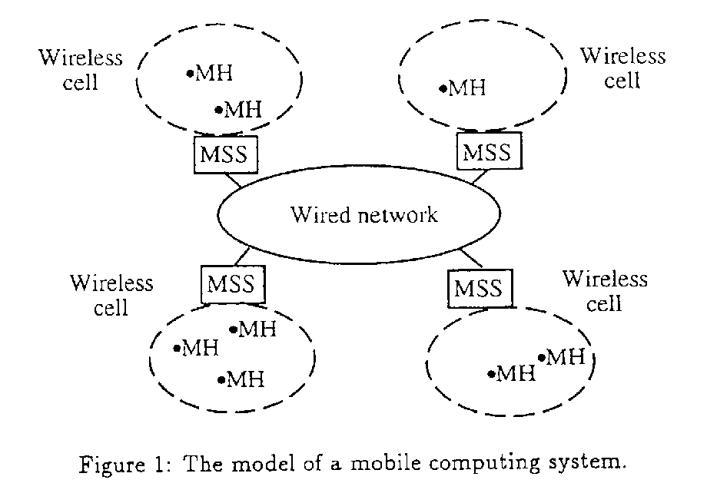
- The Algorithm
Each MSS s_{i} matains an n_{s} x n_{h} matrix called MSS_SENT_{i}.
Each MH h_{i} is associated with an n_{s}-entry vector, MH_DELIV_{i}.
Each MSS matains two message queues for each MH in its cell:
WAIT_ACK_{i} and PEND_{i}.

Message m is deliverable if MH_DELIV_{j}[k]≥m.S[k,j] for all k ∈ {1, …, n_{s}}

MH3
MH2
MH1
MSS_2
MSS_1

Created by : Kwo-Tsung Tseng
Date : May 13, 1998

